Tutorial

Prerequisites:

* Windows
* PostgreSQL 9.2
* pgAdmin III
* Python 2.7.4
* Arduino-1.0.1

Install Python 2.7.4

Install psycopg2 library for python 2.7.4

Install Arduino-1.0.4

Install json-arduino <https://github.com/not404/json-arduino>

Part 1

1. Unzip the aJson-test.zip and aJson-master.zip in the libraries of arduino-1.0.1. And make sure you have changed the names of the two directories because dash results in errors (Figure 1).

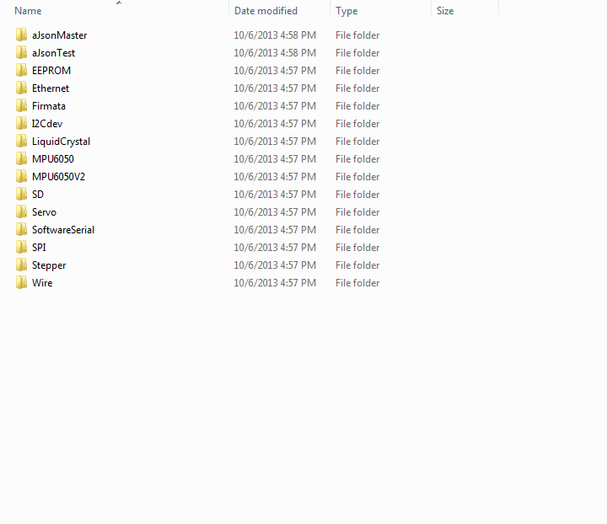

Figure 1

1. Next, open File -> Examples-> JsonMaster ->Examples -> Json_Serial (Figure 2). In order to create a Json objects, we need to change some codes in function createMessage().

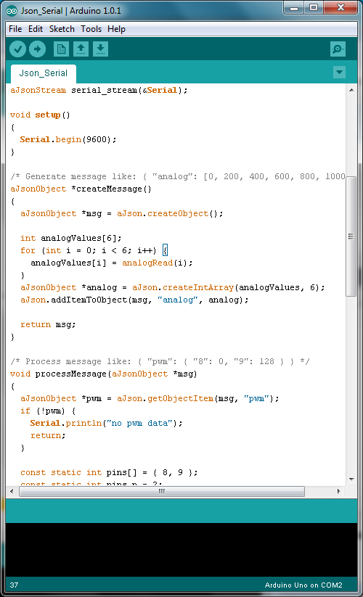

Figure 2

aJsonObject *msg = aJson.createObject(); // create a Json object

aJsonObject *id = aJson.createItem("1"); // id is 1

aJsonObject *sensor_value = aJson.createItem(analogRead(analogPin));

aJson.addItemToObject(msg, "sensor_value", sensor_value); // add key 'sensor_value' and its //value to a JSON object msg

aJson.addItemToObject(msg, "id", id); // add key 'id' and its value to a JSON object msg

return msg;

1. After uploading, we can see the results on Arduino console.

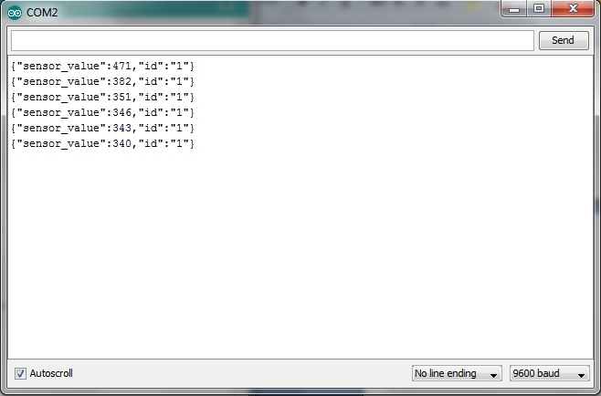

Part 2

In this part, we should display the data on Python.

1. Pycopg2 is an important library. Therefore, make sure you’ve install it correctly.
2. First, import serial and set up our serial:

**ser = serial.Serial(SERIALPORAT, 9600)**

This statement is to make a connection to the COM port where Arduino is. The following code can be used to detect which COM port is available (Figure 3). And its output shows that COM2 is used (Figure 4).

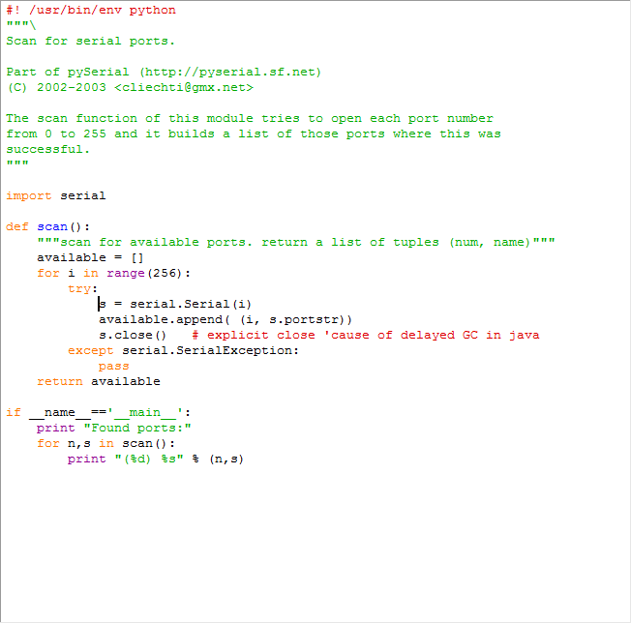

Figure 3

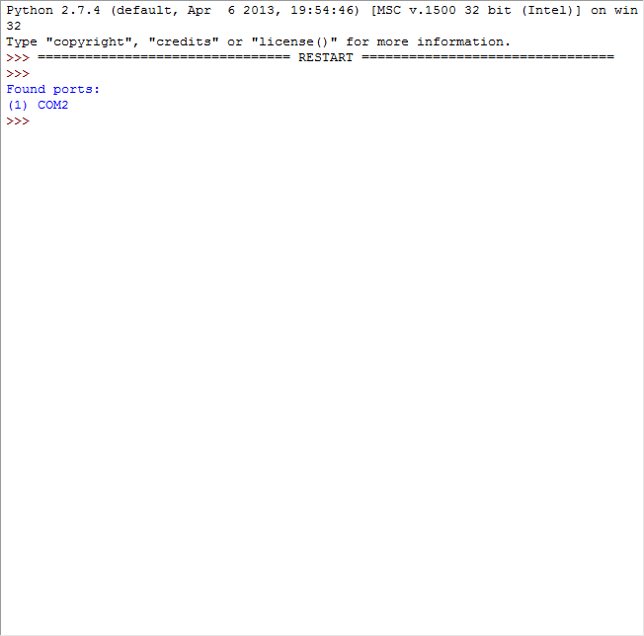

Figure 4

1. Next, we need to decode the JSON data and make it be a dictionary (Figure 5).

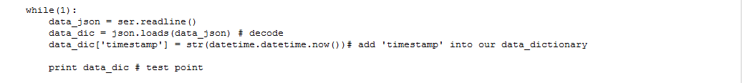

Figure 5

1. Run the module and you will see the following results (Figure 6).

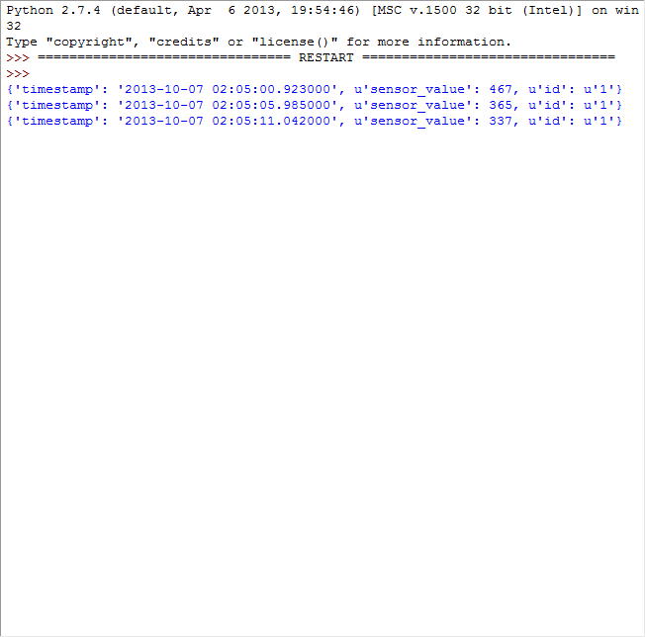

Figure 6

1. Luckily, we get the dictionary type we want.

Part 3

This part is about creating a psql database and push the real-time data into it.

1. Open File-> Add Server (Figure 7). Ensure you remember the detailed information such as host, username and password because we will use them later in our code.

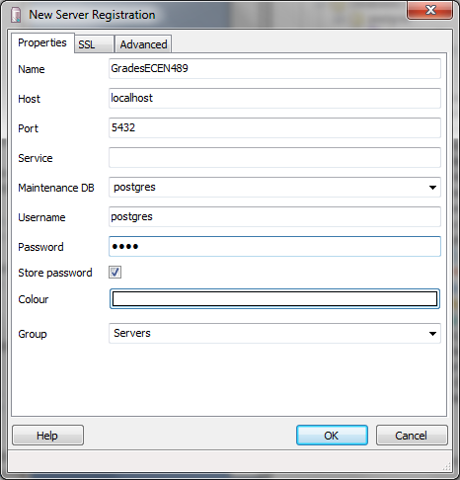

Figure 7

1. Click on OK, you will see a server named GradesECEN489 shows up under ‘Object browser’ (Figure 8).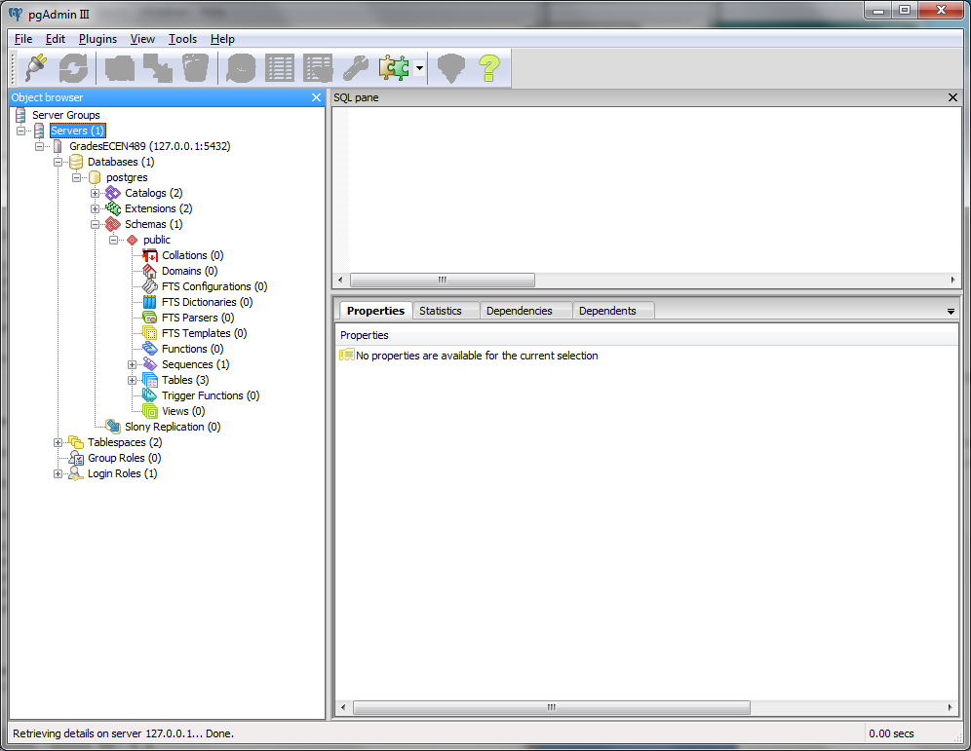

Figure 8

1. Now it is time to connect to our database and push the dictionary type data into the database (Figure 9 and Figure 10).

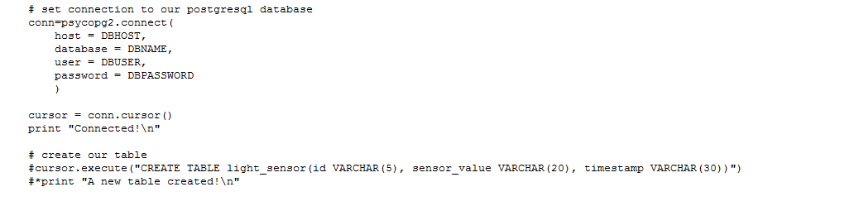

Figure 9

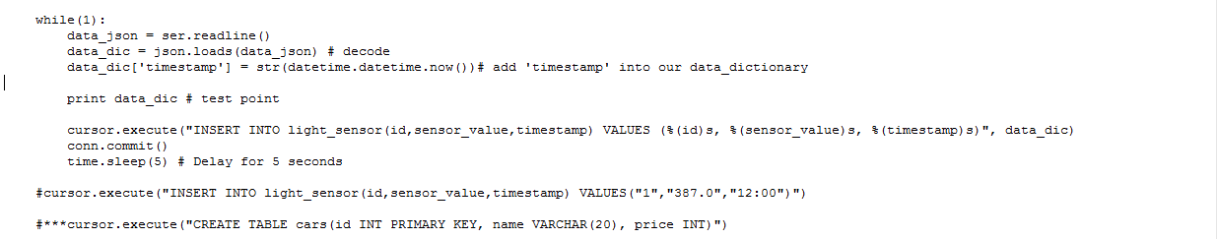

Figure 10

1. Run the module. Results can be shown on both Python console and pgAdmin III (Figure 11 and Figure 12).

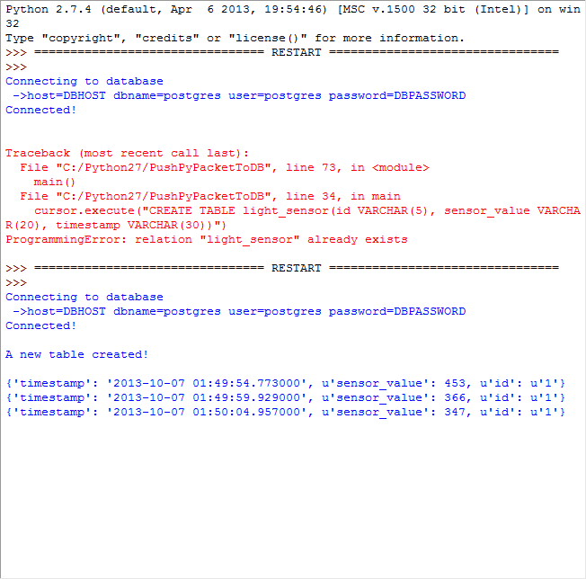

Figure 11

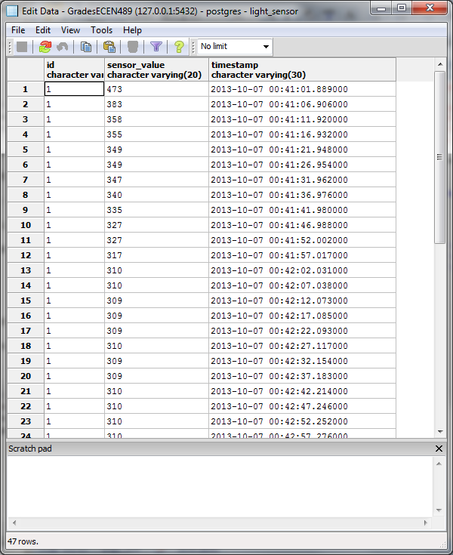

Figure 12